EduGenie – Google Gemini Powered Learning Assessment
Project Planning Document
1. Introduction
EduGenie is a Google Gemini powered learning and assessment project designed to provide students with an interactive digital learning experience. Project planning defines the activities, resources, development stages, testing process, and expected outcomes required to complete the system successfully.
2. Project Objectives
- Develop a simple and student-friendly learning platform.
- Use Google Gemini AI to support intelligent learning content and assessment.
- Provide interactive questions and automated assessment support.
- Present clear feedback and results to students.
- Create a maintainable and scalable project structure.
3. Project Planning Roadmap
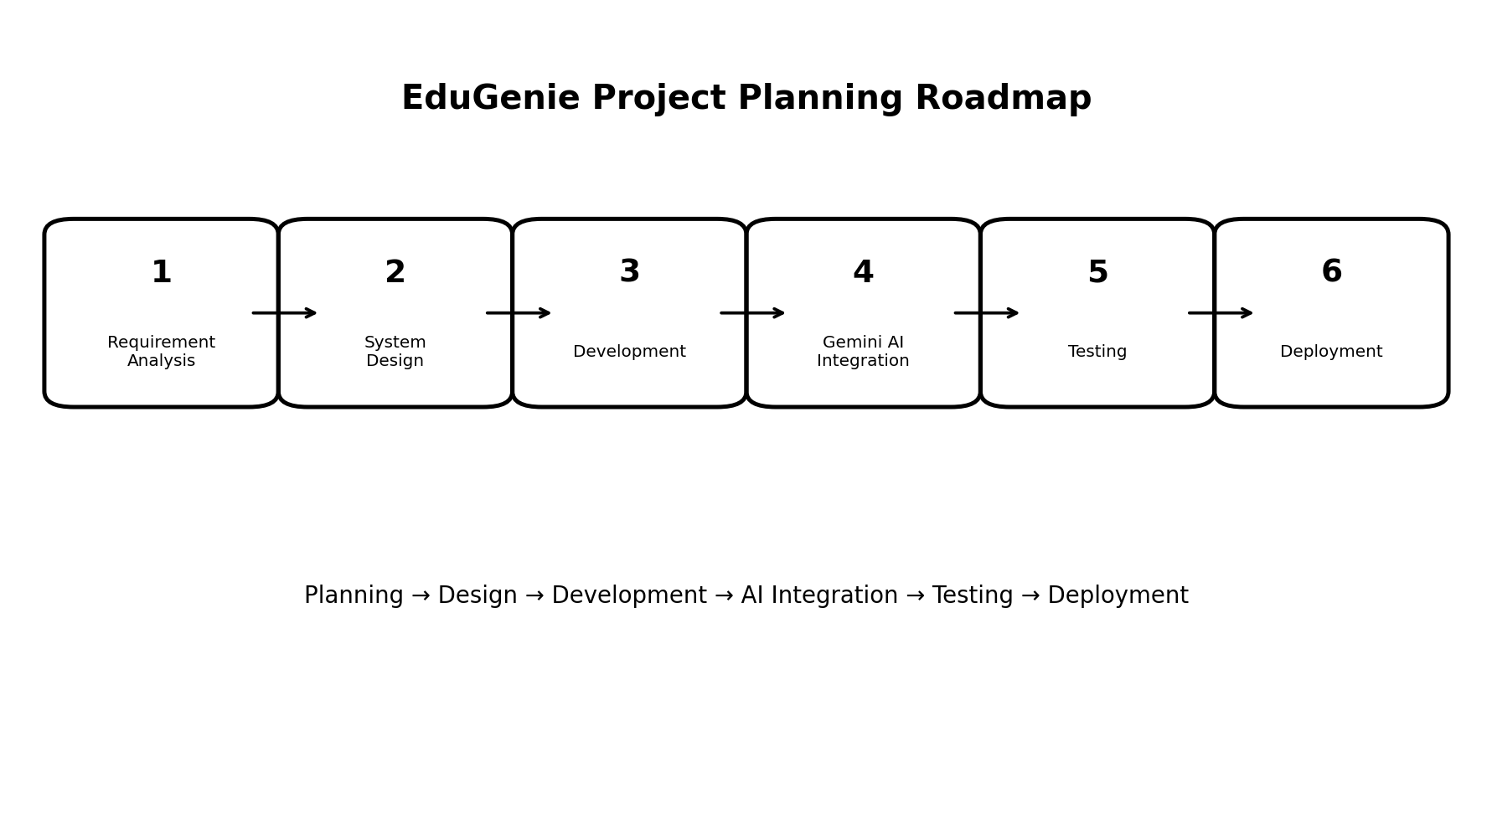
Figure 1: EduGenie project planning roadmap.
4. Project Phases
Requirement Analysis – Identify student requirements, project scope, features, inputs, and expected outputs.
System Design – Design the system architecture, database structure, API flow, and user interface.
Development – Develop the frontend, backend APIs, assessment functions, and database connectivity.
Gemini AI Integration – Connect the application with Google Gemini services for AI-assisted learning and assessment.
Testing – Test UI functions, APIs, assessment logic, AI responses, error handling, and overall workflow.
Deployment – Prepare the final application for demonstration or deployment and document the completed system.
5. Project Timeline
Phase | Suggested Duration | Main Output
Requirement Analysis | Week 1 | Requirements and project scope
System Design | Week 2 | Architecture and UI design
Development | Weeks 3–4 | Working application modules
Gemini AI Integration | Week 5 | AI-powered learning/assessment features
Testing | Week 6 | Tested and corrected application
Deployment & Documentation | Week 7 | Final project and documentation
6. Resources Required
- Development environment such as Visual Studio Code.
- Python and FastAPI for backend development.
- HTML, CSS, and JavaScript for the user interface.
- Google Gemini AI services for AI-assisted features.
- Database for storing required application and assessment data.
- Testing devices and sample learning/assessment content.
7. Testing Plan
- Functional testing – verify each feature works according to requirements.
- UI testing – check navigation, buttons, forms, and screen layout.
- API testing – verify backend requests and responses.
- AI response testing – check generated learning content and assessment responses.
- Integration testing – verify communication between frontend, backend, AI service, and database.
8. Expected Outcome
The completed EduGenie system is expected to provide an easy-to-use learning and assessment platform with Google Gemini powered capabilities. Students should be able to access learning content, participate in assessments, and receive clear results or feedback through the application.
9. Conclusion
A structured project plan helps EduGenie development progress in an organized manner. By following the planned phases from requirement analysis through deployment, the project can be developed, tested, and documented systematically. The planning roadmap also provides a clear foundation for future improvements and additional AI-powered learning features.

